**CSE 575: Statistical Machine Learning Assignment #3**

**Sushant Trivedi (1213366971)**

1. **KMEANS**
   1. **Prove that the above procedure will converge in finite steps?**

For N data points into k clusters, the total no of clusters possible are finite (equal to kN). In K-Means, in each iteration new clusters are based only on the old clustering resulting in following scenarios:

1. New cluster is same as the old cluster. Thus, same cost.
2. The new cluster is different from old cluster. The new cluster has lower cost.

In order to reach convergence, it must enter 1st situation in a loop. If its in 2nd situation, it will lead to a cluster with minimum cost as there are finite no of possible clusters. Once it enters the cluster combination with min cost, then it will enter the 1st situation. Thus, the K-Means procedure will converge in finite steps.

* 1. **Suppose we run Kmeans on the following dataset with six data points (i.e., the six black dots) to find two clusters. If we set the initial cluster centers are** **μ1 = (0, 1) and μ2 = (3, 3).**

**How many iterations does the algorithm take until convergence (3 points)?**

It takes 3 steps to converge.

**If we only run Kmeans for one iteration, what is the cluster assignment for each data point after Step-a (4 points)?**

μ1 = (1/2, 3/2) -> (0,0), (0,2), (2,0), (0,4)

μ2 = (2, 3) -> (2,4), (2,2)

**What are the updated cluster centers after Step-b (3 points)?**

μ1 = (1/2, 3/2)

μ2 = (2, 3)

1. **MIXTURE MODEL FOR DOCUMENT CLUSTERING**

**What is P (d=d1)? (You can use the following fact: 00 = 1, 10 = 1 and 01 = 0).**

**We run EM algorithm one iteration. What is the updated E[Zij] ( i=1 to 7 ; j = 1,2) after the E-step?**

Please note that the calculations are enclosed at the end.

|  |  |  |
| --- | --- | --- |
|  | **θ1** | **θ2** |
| **D1** | 1 | 0 |
| **D2** | 1 | 0 |
| **D3** | 1 | 0 |
| **D4** | 1 | 0 |
| **D5** | 0 | 1 |
| **D6** | 0 | 1 |
| **D7** | 0 | 1 |

**What is the updated P(θ1), P(θ2), θ1, and θ2, respectively, after the M-step?**

P(θ1) = 4/7

P(θ2) = 3/7

θ1 = [2/7, 2/7, 2/7, 0, 0, 1/7]

θ2 = [0, 0, 0, 3/8, 3/8, 1/4]

**If we run EM algorithm for another iteration,** **What is the updated E[Zij] ( i=1 to 7 ; j = 1,2) after the E-step?**

|  |  |  |
| --- | --- | --- |
|  | **θ1** | **θ2** |
| **D1** | 1 | 0 |
| **D2** | 1 | 0 |
| **D3** | 1 | 0 |
| **D4** | 1 | 0 |
| **D5** | 0 | 1 |
| **D6** | 0 | 1 |
| **D7** | 0 | 1 |

1. **OVERFITTING**
   1. **Bias-Variance Tradeoff**

**Assume, we are modeling a number of features using a machine learning model. Recall the relationship among bias, variance, and the complexity of hypothesis class, choose the correct answers in the following table**.



* 1. **Leave-One-Out-Cross Validation**

**Suppose we use a linear SVM (i.e., no kernel), with some large C value. What is LOOCV for your SVM? Justify your answer.**

**Ans.** LOOCV = 25 %.



The marked out points when left out affect the decision boundary such that they are incorrectly labelled in the cross validation process.

The large C value means that the SVM makes a hard margin.

**Suppose We want to train 1NN, using L2 distance. What is the LOOCV for your 1NN classifier? Justify your answers.**

**Ans.** LOOCV = 3/8

1. **PCA**

Given First Component: $u=\left(\frac{1}{\sqrt{2}}, \frac{1}{\sqrt{2}}\right)$

**Suppose we add one more data point at (4, 4), how would that affect the first principle component?**

There would be no change as its in the same vector angle as the first component.

**Suppose we add one more data point at (2, 0), how would that affect the first principle component?**

It will skew(rotate) the first component towards the x-axis.

**Suppose we add an infinite number of data points at (0, 5), how would that affect the first principle component?**

With infinite data points at (0,5) the first component would be drastically rotated towards y-axis.

Thus, the new first component would be $u=\left(0, 1\right)$

1. **IMPLEMENTING KMEANS AND GAUSSIAN MIXTURE MODEL (GMM)**

***PART-1***

1. **K-Means**

We successfully implemented k-means algorithm and the cost function vs k values are as follows.

In order to deal with empty clusters convergence, we restart every time an empty cluster is present in the collection.

1. **GMM**

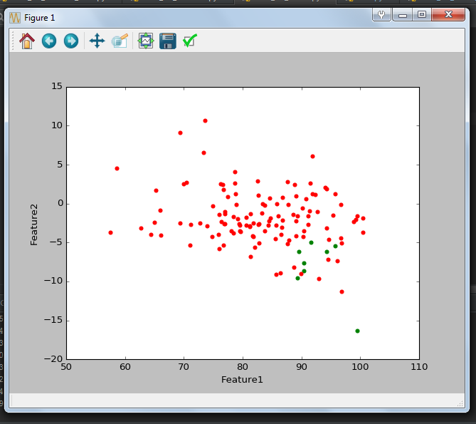

***PART-2***

1. **K-Means**
2. We first Normalize the data by using the following formula:

$X \left(Feature Value\right)= \frac{X-F_{\min{ }}}{Fmax-Fmin}$ (Code Line 30)

1. Following that we implement PCA Algorithm
2. Next, we apply K-Means Algorithm

**NOTE:** Please see that in code line 28 we had added np.random.seed(10). But that would be ineffective as we restart the iteration to compensate for empty clusters

**RESULTS**

Replacing the Step (i) with Feature Value – Mean Feature Value

1. **GMM**

